An InternshipReport on

**Process Mining virtual internship**

Submitted in partial fulfilment of the requirements for the award of the degree of

# BACHELOR OF TECHNOLOGY

in

# Computer Science and Engineering (Data Science)

by

**G . Vamsi Krishna (224G5A3214)**



**DEPARTMENT OF COMPUTER SCIENCE AND ENGINEERING (DATA SCIENCE)**

**SRINIVASARAMANUJANINSTITUTEOFTECHNOLOGY**

**(AUTONOMOUS)**

**(AffiliatedtoJNTUA,accreditedbyNAACwith‘A’Grade,ApprovedbyAICTE,New Delhi& AccreditedbyNBA (EEE,ECE&CSE)) Rotarypuramvillage,BKSamudramMandal, Ananthapuramu-515701.**

# 2023-2024

**SRINIVASARAMANUJANINSTITUTEOFTECHNOLOGY**

**(AUTONOMOUS)**

**(AffiliatedtoJNTUA,accreditedbyNAACwith‘A’Grade,ApprovedbyAICTE,New Delhi& AccreditedbyNBA (EEE,ECE&CSE)) Rotarypuramvillage,BKSamudramMandal, Ananthapuramu-515701.**

## Department of Computer Science & Engineering (Data Science)



Certificate

This is to certify that the internship report entitled “Process Mining Virtual Internship” is the bonafide work carried out by **G Vamsi Krishna** bearing Roll Number 224G5A3214 in partial fulfilment of the requirements for the award of the degree of **Bachelor of Technology** in **Computer Science and Engineering (Data Science)** from May 2023 to July 2023

#### Internship Coordinator Head of the Department

Mr. P. Veera Prakash, M.Tech., (Ph.D.), Dr. P. Chitralingappa, M.Tech., Ph.D.,Assistant Professor& HOD of CSE Associate Professor

Date: **EXTERNAL EXAMINER**

Place: Ananthapuramu

## PREFACE

Brief overview of the company’s history:

Celonis was founded in 2011 by three entrepreneurs: **Bastian Nominacher, Alexander Rinke, and Martin Klenk.** The company's primary purpose is to help businesses optimize their internal processes through data-driven insights. Process mining, their core technology, involves analyzing data from various sources within an organization to visualize and understand how processes are actually being executed. This enables companies to identify bottlenecks, inefficiencies, and areas for improvement in their operations.

Over the years, Celonis has grown significantly and has become a leader in the field of process mining. They've developed a suite of software solutions that empower organizations to not only analyze their processes but also take action to improve them in real-time.Celonis was created with the aim of revolutionizing the way businesses approach process optimization and improvement. The company specializes in process mining, which involves analyzing data from various sources within an organization to gain insights into its operational processes. By visualizing these processes and identifying inefficiencies and bottlenecks, Celonis enables organizations to streamline their operations, enhance efficiency, and drive continuous improvement.

Business Activities:

The company expanded its presence globally, serving a wide range of industries, including manufacturing, finance, healthcare, and more.

Partnerships and Integrations: Celonis has formed partnerships with other technology providers and has integrated its solutions with popular business software platforms to offer seamless solutions to its customers.

Company’s Mission Statement:

**"To unleash the power of Process Mining technology and transform the way businesses operate, making their processes more transparent, efficient, and automated."**

# ACKNOWLEDGEMENT

The satisfaction and euphoria that accompany the successful completion of any task would be incomplete without the mention of people who made it possible, whose constant guidance and encouragement crowned our efforts with success. It is a pleasant aspect that I have now the opportunity to express my gratitude for all of them.

It is with immense pleasure that I would like to express my indebted gratitude to my internship coordinator **Mr. P. Veera Prakash,Assistant Professor& HOD,Department of Computer Science and Engineering**,who has supported me a lot and encouraged me in every step of the internship work. I thank him for the stimulating support, constant encouragement and constructive criticism which have made possible to bring out this internship work.

I am very much thankful to **Dr. P. Chitralingappa, Associate Professor & HOD, Computer Science and Engineering (Data Science),** for his kind support and for providing necessary facilities to carry out the work.

I wish to convey my special thanks to **Dr. G. Balakrishna, Principal** of **Srinivasa Ramanujan Institute of Technology** for giving the required information in doing my internship. Not to forget, I thank all other faculty and non-teaching staff, and my friends who had directly or indirectly helped and supported me in completing my internship in time.

I also express our sincere thanks to the Management for providing excellent facilities and support**.**

Finally, I wish to convey my gratitude to my family who fostered all the requirements and facilities that I need.

#### G VamsiKrishna

#### 224G5A3214

**INDEX**

**Contents Page No.**

List of Figures v

List of Abbreviations vi

Chapter 1 Introduction to Process Mining 01-06

* 1. What is Process
  2. Process Mining
  3. Use cases

Chapter 2 Process Mining : 06-10

Chapter 3 Learn to get data 11-15

* 1. Introduction to SQL & PQL
  2. SQL vs PQL
  3. Get Data into the EMS

|  |  |  |
| --- | --- | --- |
| Chapter 4 | Applications | 16-20 |
| Chapter 5 | Real Time Examples | 21-24 |
| Chapter 6 | Process Mining Tools | 25-29 |
| Chapter 7 | Outcomes of Internship that are learned by student. | 30 |
| Conclusion |  | 31 |
| References |  | 32 |

**List of Figures**

|  |  |  |
| --- | --- | --- |
| **Fig.No.** | **Description** | **Page No.** |
| 1.1 | Process | 2 |
| 1.2 | Process Mining | 3 |
| 1.3 | Key process mining use cases | 4 |
| 2.1 | Implementing Process Mining | 8 |
| 2.2 | Steps involved in process mining | 10 |
| 3.1 | PQL Engine | 11 |
| 3.2 | Comparison of SQL and PQL | 12 |
| 4.1 | Process Mining & RPA | 17 |
| 4.2 | Process Mining& Supply chain | 18 |
| 5.1 | Order Management | 21 |
| 5.2 | Auditing | 23 |
| 6.1 | Process Mining Tools | 26 |

**LIST OF ABBREVIATIONS**

|  |  |
| --- | --- |
| NPS | Net Promoter Score |
| KPI | Key Performance Indicators |
| PQL | Process Query Language |
| SQL | Structured Query Language |

# CHAPTER 1 INTRODUCTION TO PROCESS MINING

## What is Process ?

A process is a systematic series of actions, tasks, or steps that are executed in a specific sequence to achieve a desired outcome or goal. Processes are fundamental to various fields, including business operations, manufacturing, software development, and more. They provide structure and organization to activities, ensuring that tasks are performed in an orderly and efficient manner.

Here are the general steps typically involved in a process:

#### Identification or Definition:

The first step involves identifying the need for a process or defining what needs to be achieved. This could be a business goal, a task to complete, or a problem to solve.

#### Planning:

This step involves mapping out the entire process, including defining the scope, objectives, resources needed, and the sequence of actions. It's essential to outline the "big picture" before delving into the details.

#### Design:

In this phase, the process is designed in detail. Each action or step is defined, along with the inputs, outputs, roles and responsibilities, and any specific requirements.

#### Execution:

This is where the actual work begins. The defined steps are executed according to the predetermined sequence. Each action is carried out, and tasks are completed by the individuals responsible.

#### Monitoring:

During execution, the process is monitored to ensure that everything is proceeding as planned. This involves tracking performance metrics, timelines, and quality standards.

#### Control and Adjustments:

If any deviations or issues are identified during monitoring, corrective actions are taken to bring the process back on track. This could involve making adjustments, resolving bottlenecks, or addressing unexpected challenges.

#### Completion:

Once all the required steps are executed and the desired outcome is achieved, the process is considered complete. The final outputs are generated and delivered.

#### Evaluation:

After completion, the process is evaluated to determine its effectiveness. This could involve analyzing whether the goals were met, whether improvements are needed, and what lessons were learned.

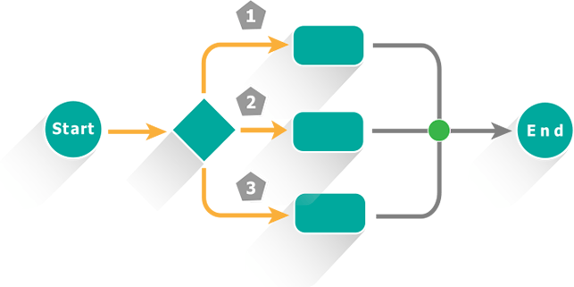

Fig 1.1 : Process

#### Documentation:

Thorough documentation is crucial throughout the entire process. This includes recording details about each step, decisions made, deviations encountered, and outcomes achieved. Proper documentation facilitates future reference, improvement efforts, and compliance.

## Process Mining :

Most businesses have only a rudimentary knowledge of how their processes work. In the last decade or two, process mining has become a critical enabler for business intelligence and business process management. It has become an essential part of the modern business landscape, from banking and financial services to telecommunications, energy, healthcare, logistics, and manufacturing. Many companies gain valuable insights from mining their processes, allowing them to review thoroughly and devise action plans.

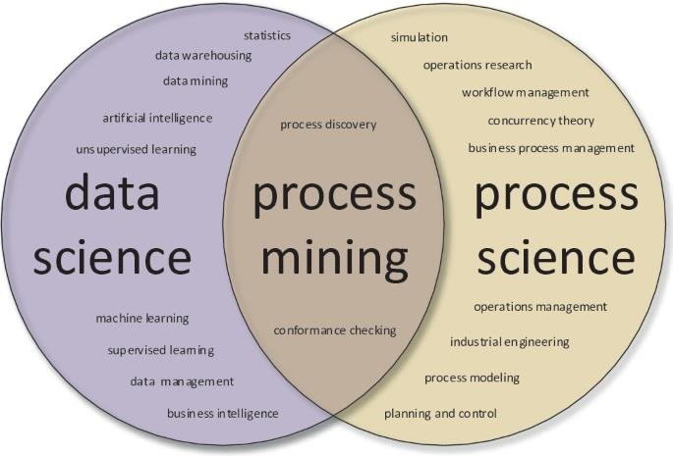

**Fig 1.2 : Process Mining**

## Types of Process Mining:

Process mining encompasses various techniques and approaches that cater to different aspects of analyzing and improving processes. There are several types of process mining that focus on different aspects of the process lifecycle. Here are three common types:

#### Discovery:

Process Discovery involves automatically creating a process model from event data. This type of process mining is used to gain insights into how processes are executed in reality, even if there is no pre-defined process model available. It helps to uncover the actual flow of activities, decision points, and paths taken by process instances. The resulting process model can be visualized as a flowchart or a Petri net, revealing the interactions and variations in the process.

#### Conformance:

Conformance analysis compares the actual execution of processes (captured in event data) against the expected or desired process model. This type of process mining aims to identify deviations, non-compliance, and variations between the documented process and how it's actually being executed. By comparing the "as-is" process with the "to-be" process, organizations can pinpoint areas where processes are not adhering to the intended design and take corrective actions.

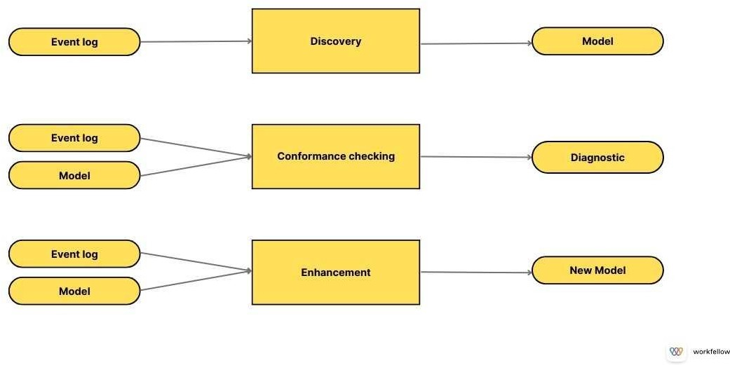

#### Enhancement:

Fig 1.3 : Key process mining use cases

Process Enhancement, also known as Performance Analysis or Extension, involves using process mining to analyze process data and identify areas for improvement. This type of process mining focuses on optimizing process efficiency, reducing

bottlenecks, and enhancing overall performance. By analyzing performance metrics, organizations can make informed decisions to streamline processes, reallocate resources, and optimize the flow of activities.

## Use Cases of Process Mining:

Process mining has a wide range of uses across different industries and sectors. Its applications span from improving operational efficiency to ensuring compliance and driving digital transformation. Here are some key uses of process mining:

Process mining has a wide range of uses across different industries and sectors. Its applications span from improving operational efficiency to ensuring compliance and driving digital transformation. Here are some key uses of process mining:

**Process discovery :** This is the most typical and more generic use case for process mining is process discovery where the goal is to identify the "as-is" state of business processes.

**Root-cause analysis :** Another key use case is simply quantifying and identifying the root cause of key process challenges by using real process data.

**Conformance checking :** Process mining allows you to monitor and continously track processes alignment to SOPs and process models through conformance checking.

**Opportunity identification :** Process mining uncovers opportunities to streamline or automate processes, for example, with robotic process automation (RPA).

**Process optimization :** In process optimization, the end-state of effective process mining is that processes are continously monitored and improved.

### Some common use-cases for process mining in enterprise business include:

1. **Finance** - improving working capital, increasing productivity of the finance team, or ensuring compliance within financial operations.
2. **Procurement** - simplifying approval processes, reducing maverick buying, or identifying errors in supplier performance.
3. **Customer service** - reducing the lead time of customer response, identifying root- causes of issues, improving customer satistaction.

# CHAPTER 2 IMPLEMENTATION OF PROCESS MINING

Implementing process mining involves several steps that require careful planning, collaboration, and technological integration. Here's a general outline of how to implement process mining effectively:

#### Identify the process(es) to be analyzed:

The first step in implementing process mining software is to identify the processes that you wish to analyze. These could be procurement, manufacturing, customer service, or any other business process. It's essential to have a clear understanding of your business processes and where you think improvements can be made.

#### Collect or integrate data:

Once you have identified the processes, the next step is data collection. The software will need access to event logs from the systems related to the processes being analyzed. These could be ERP systems, CRM systems, databases, and more. The quality of data directly influences the effectiveness of process mining, so ensure the data is complete and accurate. In some process mining tools data can be extracted directly from source systems, while other tools use Excel files for import/export of data

#### Verify data quality:

After your process data has been collected, you often need to verify that the data is accurate and reliable. Some preprocessing might be required to clean the data and make it suitable for analysis. This may involve removing outliers, dealing with missing values, and transforming data into a suitable format. It is a good idea to include subject matter experts in data validation exercises, to make sure that the data collected matches the real-world views of the people doing the work.

#### Analyze the data:

Once the data is uploaded and verified, process mining algorithms can be run to produce visualizations and analytics. Process mining algorithms are used across different use-cases to discover patterns, dependencies, and trends in the data. This will provide you with a visual representation of the process, allowing you to see where there are bottlenecks or inefficiencies.

#### Interpret the results and implement changes:

Finally, it's time to interpret the results and implement changes. This is where the real value of process mining comes into play. By understanding where inefficiencies lie, you can make informed decisions to improve these areas.

#### Monitor and adjust:

The implementation of process mining software is not a one-off task. It's a continuous process that requires monitoring and adjusting. You'll need to continuously collect data, analyze it, and implement improvements based on the findings. This will allow you to keep up with changes in your business environment and ensure continuous improvement.

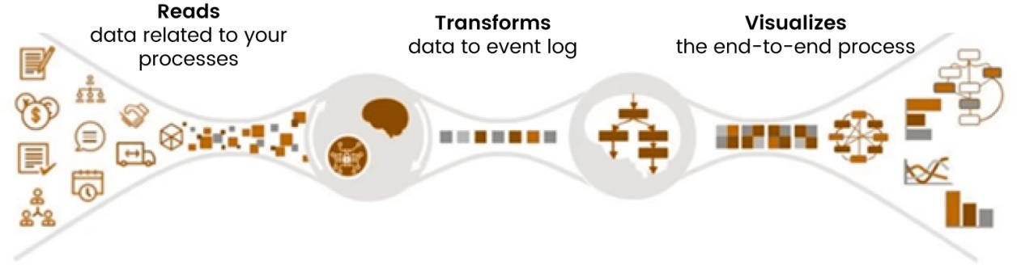

**Fig 2.1 : Implementing Process Mining**

Process mining provides insights into how processes are actually executed within an organization, enabling data-driven decisions for optimization and improvement. Here are some possible solutions that process mining can offer:

#### Process Optimization:

Process mining helps identify bottlenecks, inefficiencies, and delays in processes. By analyzing the actual execution data, organizations can make targeted improvements to streamline workflows, reduce waiting times, and enhance overall efficiency.

#### Performance Enhancement:

Process mining provides metrics to measure process performance. Organizations can analyze cycle times, processing times, and resource utilization to identify areas where performance can be enhanced.

#### Bottleneck Identification and Resolution:

Process mining identifies bottlenecks where processes slow down or resources are underutilized. This enables organizations to focus their efforts on resolving these bottlenecks and improving overall process flow.

#### Compliance Monitoring:

Process mining ensures that processes adhere to regulations, standards, and internal policies. It helps in detecting non-compliance deviations and taking corrective actions to avoid penalties and reputational risks.

#### Root Cause Analysis:

By analyzing the data, process mining uncovers the root causes of inefficiencies or deviations. Organizations can address underlying issues and prevent future occurrences.

#### Process Redesign:

Based on insights gained from process mining, organizations can redesign processes to be more efficient and effective. This might involve reordering steps, reallocating resources, or introducing automation.

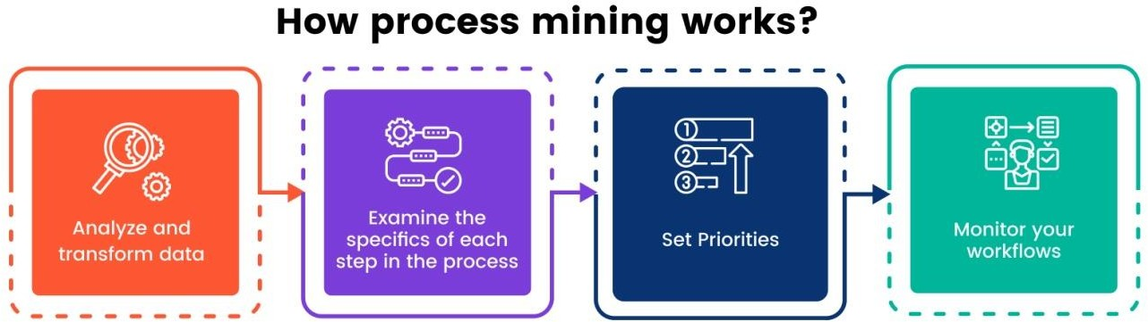

#### Fig 2.2:Steps involved in process mining

1. **Resource Allocation:**

Process mining reveals how resources are used throughout a process. This insight assists organizations in allocating resources more effectively, reducing overutilization or underutilization.

#### Predictive Analysis:

Advanced process mining tools can predict future process behavior based on historical data. This helps organizations anticipate potential issues and make proactive decisions.

#### Continuous Improvement:

Process mining fosters a culture of continuous improvement. Organizations can regularly monitor processes, analyze data, and make incremental changes for ongoing enhancement.

# CHAPTER 3 LEARN TO GET DATA

## Introduction to pql and sql

The intention of Celonis PQL is to provide a query language for performing process mining tasks on large amounts of event data. It is based on a relational data model. Currently, the supported data types comprise STRING, INT, FLOAT, and DATE. Boolean values are not directly supported but can be represented as integers. Each data type can hold NULL values. In general, Celonis PQL treats NULL values as non-existing and ignores them in aggregations. Also, row-wise operations like adding the values of two columns will return NULL if one of its inputs is NULL.

Currently, Celonis PQL provides more than 150 different operators to process event data. Due to space limitations, we cannot sketch the full language. However, we can offer a briefoverview of the major language features before

## Language Overview

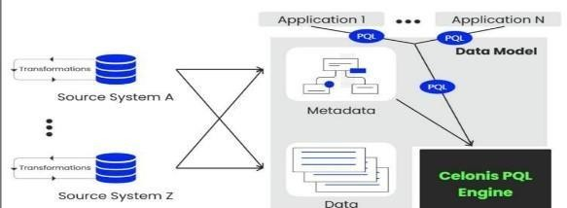Even though Celonis PQL is inspired by SQL, there are major differences between the two query languages. Figure 6 shows these differences by comparing how to query the cases and the number of departments involved for all orders with a value of more than 1000 eurosin both languages. Furthermore, it also illustrates the key concepts of Celonis PQL.

**Fig 3.1: PQL Engine**

## SQL VS PQL

Both languages offer the possibility to filter rows. While SQL requires the user to formulate the filter condition in the WHERE clause of the query, Celonis PQL offers the FILTER statements which are separated from the TABLE statements but executed together. Splitting the data selection and the filters into different statements enables the user to define multiple filter statements in different locations inside an application, which then can be combined into the table statement to query the data.

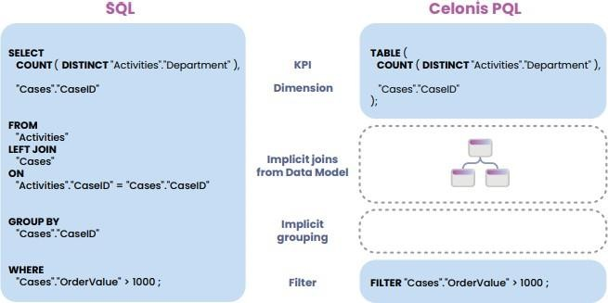Beyond this simple structure, Celonis PQL provides a wide range of different operators which can be combined to answer complex business questions. The following list gives an overview of the most important classes of operators.

## Aggregations.

#### Fig 3.2: Comparison of SQL and PQL

Celonis PQL offers a wide range of aggregation functions, from simple standard functions like count and average, to more advanced aggregations like standard deviation and quantiles. Most of the aggregation functions are also available as window-based functions computing the aggregation not over all values but over a user-defined sliding element window.

## Data functions

These are operators like REMAP_VALUES and CASE WHEN which allow for conditional changes of values.

## Date and time functions.

These functions enable the user to modify, project or round a date or time value, e.g.,

add a day to a date or extract the month from a timestamp. There are also functions to compute date and time differences

## Get Data into the EMS:

In this topic we will study about two types they are Set up a data pipelineRefine your Data PipelineIn the set up a data pipeline again divide into sub parts they are

* + - Data Integration basics
    - Connect to Systems
    - Extract Data
    - Transform Data
    - Load a Data Model

In the Refine your Data Pipeline divide into parts they are:

* + - Schedule Data Jobs
    - Monitor and validate your Data pipeine
    - Multiple Process and Systems
    - Boost your EMS SQL Transformations 5.Connect Custom processes
    - Quality Assuring your Data Pipeline

#### Data Integration basics

As a data engineer or analyst working in Data Integration (formerly known as Event Collection), you’re responsible for bringing in clean, real-time process data into the EMS.

#### Connect to Systems

Connecting to source systems is your very first step to pull process data into the Celonis EMS. The EMS utilizes a broad set of technologies like message queues, Restful APIs, Soap APIs, direct database access, or system-specific solutions to connect.

#### Data Integration in the EMS

Data Integration is where you set up connections and your data pipeline. The main ways you can bring data into the EMS are:

* + Process Connectors
  + Extractors Data Connections
  + Extractor Builder
  + File Uploads
  + Data Push API
  + Celoxtractor

#### Extract Data:

No matter which system you’re working with when extracting data, it’s a good idea to first understand the business process to know exactly which tables you need.

Why don’t we extract entire databases and make our lives simple?

For simple reasons—entire database extractions would take too long,be taxing on source systems,take up unnecessary cloud storage, and be expensive!

#### Transform Data:

The Activity table represents your process and always contains at least these three columns that map your process:

The object ID or case key,the process steps or activities that took place for the different case keys and the timestamps or event time of each activityEvery Purchase Order Item goes through different activities such as creating the request, creating the item, receiving goods, and paying the invoice. And every activity has a corresponding event time.

#### Load a Data Model:

Just the Activity table on its own in a Data Model is not enough. To be able to drill down into case information, we need the Case table and other master data tables. As you know, in Celonis, the Case table is a table containing one row for each case. In

other words, this table contains a row for each "process path" (a path following a case) being analyzed in the application.

By specifying a Case table, you're able to use predefined KPIs in the Celonis analysis, such as a case count. The case count now specifically refers to table “EKPO” and will always count the number of entries in this table with respect to the applied filters. This a screenshot from the Studio showing what is behind the KPI.

# CHAPTER 4 APPLICATIONS

Italian management consulting company HSPI [publishes](https://www.hspi.it/2020/01/database-delle-applicazioni-di-process-mining-2020/) a database of process mining scomplete list of process mining adoptions, increase awareness, and explore business potential. In the [2020 application database,](https://www.hspi.it/wp-content/uploads/2020/01/HSPI_Process_Mining_Database_2020.pdf) there are 551 case studies from 27 countries around the world, proving the spread of process mining adoption and growth of interest in these techniques.Several application cases to demonstrate the value and effectiveness of process mining.

## Process mining and RPA :

[Robotic process automation](https://www.altexsoft.com/blog/robotic-process-automation/) or RPA is focused on automating repetitive business processes to increase efficiency. [QPR,](https://cdn2.hubspot.net/hubfs/5483023/Products/QPR%20ProcessAnalyzer/QPR%20ProcessAnalyzer%20Product%20Page/QPR%20ProcessAnalyzer%20-%20Overview.pdf) one of the largest providers of process mining software, claims that process mining can reduce RPA implementation time by 50 percent and RPA project risk by 60 percent. And according to [UiPath,](https://www.uipath.com/rpa/what-is-process-mining) one of the leading RPA companies, *“*78 percent of people who automate say process mining is key to enabling their RPA efforts.*”* Here’s why.

1. Process mining discovers areas that need improvement and can benefit from automation.
2. Processes can be optimized to ensure that you’re not automating a mess.
3. Process maps can be used as a guide or template to train bots**,** outlining the sequence of necessary steps.
4. Process mining helps assess results and monitor RPA KPIs.
5. With the help of advanced tools, you can simulate the workflow to predict how RPA implementation impacts performance.

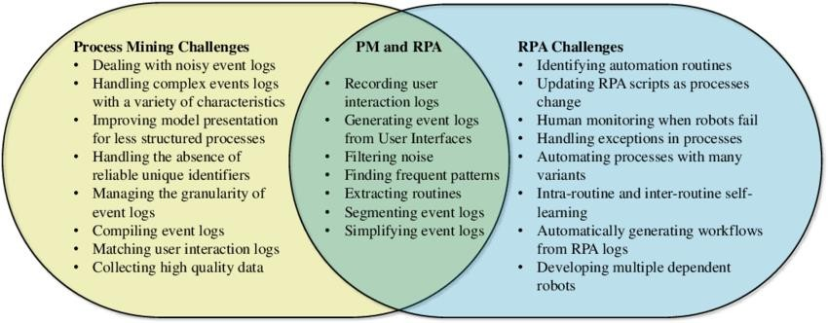

#### Fig 4.1: Process Mining & RPA

Vodafone, a multinational telecom giant, [partnered with Celonis,](https://spendmatters.com/2018/06/07/achieving-a-successful-robotic-process-automation-implementation-a-case-study-of-vodafone-and-celonis/) the world leader in process mining, for an RPA project. One of the aspects that required automation was purchase order (PO) processing as Vodafone wanted to improve its rate of 73 percent correctly completed POs. Before actually launching RPA, process mining was implemented to understand process variations and noncompliance and prepare for automation.

Alexander Rinke, co-founder and co-CEO of Celonis, emphasizes the importance of process analysis and optimization BEFORE starting an RPA project: “If a process is already flawed, RPA will only make a bad process faster. It’s essential that businesses take a transparent approach to RPA, ensuring that automated processes are first optimized to be the most efficient.”

As a result of process mining and RPA implementation, in the first six months Vodafone achieved a PO rate of 85 percent followed by a reduction in operational purchasing costs by 11 percent and a reduced time to market by 20 percent. Eventually, Vodafone managed to further increase its PO rate up to 92 percent.

#### Process mining and supply chain

Process mining offers a lot of optimization opportunities to the complex, multifaceted [supply chain](https://www.altexsoft.com/blog/supply-chain-management-software/) manufacturing, [warehousing,](https://www.altexsoft.com/blog/warehouse-management-systems/) [transportation,](https://www.altexsoft.com/blog/transportation-management-system/) [inventory](https://www.altexsoft.com/blog/inventory-management-software/)

[management,](https://www.altexsoft.com/blog/inventory-management-software/) [retail](https://www.altexsoft.com/ecommerce-retail/) management, etc. Some of the typical processes that are often performed inefficiently and require improvement include

* procure to pay,
* order to cash,
* production process,
* warehouse operations, and
* accounts payable/accounts receivable management.

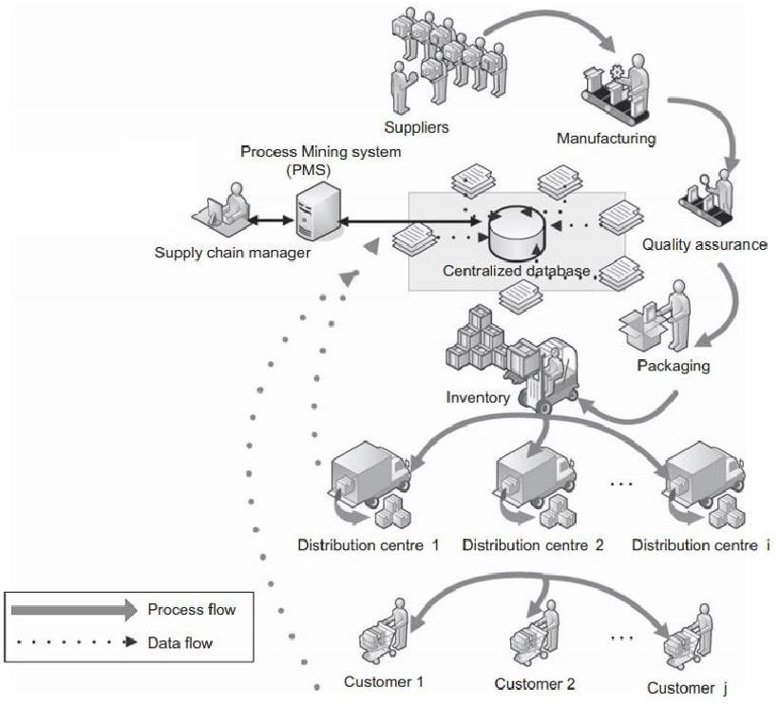

#### Fig 4.2 : Process Mining& Supply chain

Twenty-two percent of respondents to a [PwC study](https://www.pwc.be/en/FY20/documents/20191203-pwc-process-mining-are-your-business-processes-a-black-box.pdf) believe that procurement is the area that would benefit most from process mining. For example, an ideal procure to pay process is supposed to involve a short sequence of specific steps.

* Purchase request or requisition is created.
* Request is approved.
* Purchase order (PO) is created and sent to the supplier.
* Goods are delivered and approved.
* The vendor’s invoice is received.
* Payment is processed.

However, in reality, there are a number of gaps, unnecessary activities, and other weak points that add complexity and increase time of completion, often due to manual operations and poor communication. And you find out that your actual process now looks like this.

Process mining can help uncover those bottlenecks by offering full transparency into how the processes are performed in your organization.In 2016, Veco Precision, the world-leading manufacturer of precision parts, [won](https://insights.vecoprecision.com/veco-wins-process-mining-of-the-year-award) the Process Miner of the Year award after successfully applying process mining techniques to their manufacturing workflow.

Veco [partnered with Fluxicon,](https://fluxicon.com/pmoty/2016/) another major process mining vendor, to reduce their manufacturing lead times. Fluxicon combined process mining analytical capabilities with the traditional process management approaches. As a result, they managed to identify process variations and missing links, reduce factory lead times, and increase efficiency as the same amount of work could be performed with fewer workers.

That was the first stage of their process mining journey. Inspired by the results, Veco kept applying process mining tools to analyze its performance. They also hired a [data scientist](https://www.altexsoft.com/blog/datascience/how-to-structure-data-science-team-key-models-and-roles/) to further discover opportunities for process improvement and trained more people in [big data](https://www.altexsoft.com/blog/big-data-analytics-explained/).

In 2017, Veco [reported](https://static.fluxicon.com/camp/slides/2017/6-camp2017-mick-veco.pdf) on another success. As part of their development strategy, they wanted to produce new samples and deliver them to customers within 15 days — a process that then took 52 days. So, after analyzing data from their internal systems, they found the reasons for delays and had to define a new process “Engineer to Order” that required a completely different management approach.

As Mick Langeberg, the supply chain manager in Veco, announced, “The pilot results were jaw-dropping and gave us the green light to implement the new design. After we mined the customer journey, Veco has been consistently growing new business at an accelerated speed.”

#### Process mining and finance

For financial institutions, such as banks, insurance companies, or loan associations, the biggest operational priorities are security, accuracy, and speed of transactions. However, just like in any other industry, a lot of organizations suffer from inefficiencies, bottlenecks, and poor process management.

In 2018, Piraeus Bank, a Greek multinational financial services company, encountered problems after adopting RPA to automate the consumer loan process. Since traditional analytical methods proved to be of little value, [they implemented](https://cdn2.hubspot.net/hubfs/5483023/Customers/Piraeus%20Bank/Piraeus%20Bank%20-%20Unprecedented%20transparency%20to%20consumer%20loans.pdf?hsCtaTracking=799cc8ca-3ebe-4536-adb0-dc3d31678d0e%7C9116f76e-20be-4a02-9206-7386e1a84e86) [QPR Process Analyzer](https://cdn2.hubspot.net/hubfs/5483023/Customers/Piraeus%20Bank/Piraeus%20Bank%20-%20Unprecedented%20transparency%20to%20consumer%20loans.pdf?hsCtaTracking=799cc8ca-3ebe-4536-adb0-dc3d31678d0e%7C9116f76e-20be-4a02-9206-7386e1a84e86) to gain a deeper understanding of their process problems and identify bottlenecks.

The process analysis quickly revealed that *“*the main pain point was a lack of standardization of the consumer loan process and multiple inefficient variants of the process”. After uncovering the problem sources, an optimization plan was developed and implemented, resulting in cutting the loan application process from 35 minutes to 5 minutes and cutting lead time of the entire loan process by 86 percent.

# CHAPTER 5 REAL-TIME EXAMPLES

#### Here are some real-time examples of how process mining is applied across various industries:

1. **Retail: Inventory Management and Fulfillment**

A retail company uses process mining to analyze its inventory management and order fulfillment processes. By tracking the flow of products from supplier to customer, they identify bottlenecks, delays, and areas for improvement. This helps in ensuring products are available when needed and reducing stockouts.

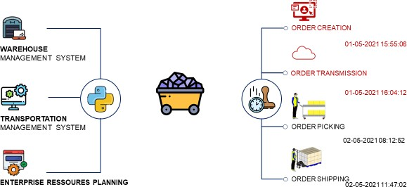

#### Fig 5.1 : Order Management

1. **Healthcare: Patient Journey Analysis**

A hospital employs process mining to map the patient journey from admission to discharge. This reveals the sequence of medical procedures, waiting times, and administrative tasks. By analyzing this data, the hospital improves patient flow, reduces wait times, and enhances overall patient experience.

#### Finance: Invoice Processing

A financial institution uses process mining to streamline its invoice processing. By analyzing the time it takes for invoices to be approved, processed, and paid, they identify steps causing delays. This helps in optimizing the process, reducing processing times, and improving vendor relationships.

#### Manufacturing: Production Line Efficiency

A manufacturing company applies process mining to its production line. By analyzing the sequence of tasks and equipment usage, they identify bottlenecks and downtime. This insight enables them to optimize production schedules, reduce downtime, and improve overall efficiency.

#### Customer Support: Helpdesk Operations

A customer support center uses process mining to analyze its helpdesk operations. By tracking the flow of customer inquiries, response times, and issue resolution, they identify areas where responses are delayed. This leads to improved customer satisfaction and more efficient support operations.

#### IT Service Management: Incident Handling

An IT department uses process mining to analyze incident handling processes. By tracking the lifecycle of IT incidents, they identify patterns of delays and repeated issues. This helps in improving incident response times, resolving recurring problems, and enhancing IT service delivery.

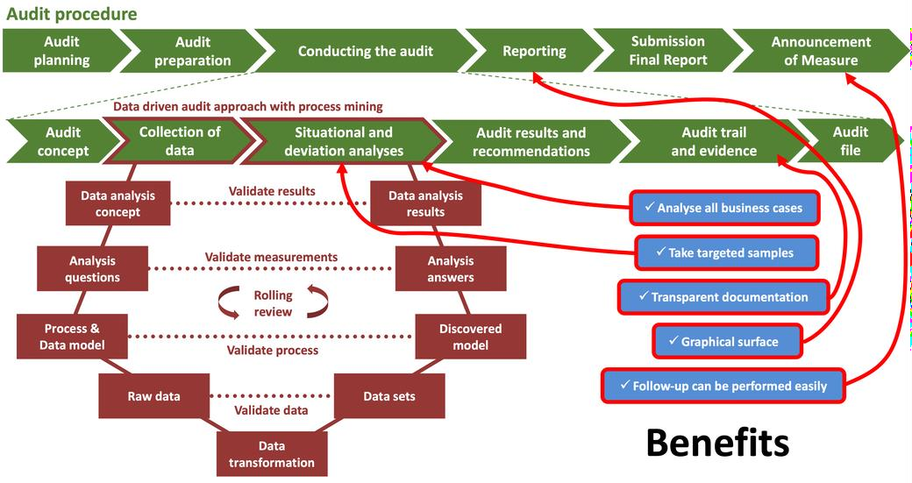

#### Fig 5.2: Auditing

1. **Logistics: Order Processing**

A logistics company employs process mining to optimize its order processing. By analyzing the steps from order placement to delivery, they identify where orders are delayed due to manual processes or transportation issues. This insight helps in enhancing order fulfillment efficiency and reducing delivery times.

#### Insurance: Claims Processing

An insurance company utilizes process mining to analyze its claims processing. By tracking the steps involved in processing claims, they identify areas of inefficiency, such as excessive back-and-forth communication. This allows them to streamline the process, reduce claims processing time, and enhance customer satisfaction.

#### Energy: Maintenance and Repairs

An energy company applies process mining to analyze maintenance and repair processes for its infrastructure. By tracking the steps from reporting an issue to resolution, they identify areas where response times are prolonged. This helps in optimizing maintenance schedules and minimizing downtime.

#### HR Process Mining:

Process mining is a game-changer for HR departments, enabling data-driven insights into employee performance, recruitment, and retention.By analysing HR processes, organizations can identify bottlenecks, streamline workflows, and improve employee engagement.

For example, process mining can help HR departments:

* + Identify the most effective recruitment channels
  + Optimize onboarding processes
  + Reduce the time to fill open positions

# CHAPTER 6 PROCESS MINING TOOLS

## What is process mining tools:

Process mining tools are software applications used to analyze and visualize business processes based on event data stored in information systems. These tools aim to provide insights into how processes are actually executed within an organization, identifying inefficiencies, bottlenecks, compliance violations, and opportunities for optimization.

#### What to consider when choosing process mining tools

When selecting process mining software, there are several key considerations that should be taken into account.

* + **Scope of analysis:** The software should be able to provide a comprehensive analysis of the process data, making use of both current and historical data.
  + **Granularity of insights:** The process mining tool should also be able to provide accurate insights into inefficiencies and bottlenecks, and provide an easy-to-use interface that makes it simple to identify and assess new and existing processes.
  + **Integration needs:** Many process mining solutions require access to event logs from different source systems. If you have a fragmented enterprise software landscape you'll need to consider how much integration effort will be required to data mine key processes.
  + **On-premise or cloud:** While many process mining software solutions are today offered as software-as-a-service (SaaS) some organizations may require on-premise solutions.
  + **Total cost of ownership:** While every organization will have different resources to implement a process mining tool, you should consider the total cost of implementation including both the price and resources required to achieve results.

#### Top Process Mining Software and tools:

Both process and task mining are thriving sectors of enterprise software with an increasing number of different vendors offering unique solutions.

#### Workfellow Process Intelligence:

Workfellow is one of the newest process intelligence solutions offering advanced process mining functionality. Unlike traditional process mining software, it does not require access to enterprise system event logs - rather it collects process insights straight from the user interface using generative AI event log technology.

Workfellow specializes in uncovering inefficiencies and automation potential in complex business processes - and provides [advanced process](https://www.workfellow.ai/guides/process-intelligence) [intelligence](https://www.workfellow.ai/guides/process-intelligence) capabilities in tracking workflows across different business processes, systems and web applications. In this sense, Workfellow is both a process and task mining solution, offering complimentary functionality for a cloud-first world through a method called Work API.

#### Top features:

* + Fast and simple implementation
  + Analyze processes, work and systems
  + End-to-end visibility

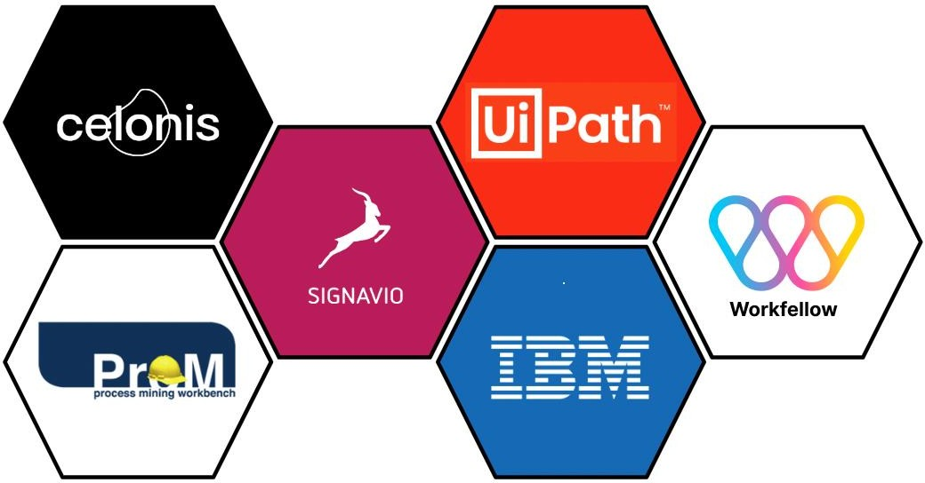

#### Fig 6.1: Process Mining Tools

1. **Celonis Process Mining**

If you’ve heard of process mining you’ve probably heard of Celonis. Founded in 2011, Celonis was one of the first commercially available solutions on the market offering a full range of process discovery, analytics, conformance checking and process improvement solutions. As of today, Celonis has raised over $2,3 Billion in investment funding, most recently in August 2022 from the Qatar Wealth Fund.

The Celonis process mining platform is called the Execution Management System (EMS). In addition to traditional process mining functionality, the EMS offers a cloud-based solution for real-time data extraction and analysis, as well as task mining functionality. Celonis EMS also includes process modeling and process simulation functionality.

#### Top features:

* + Wide adoption
  + Integrations
  + Customization
  + Broad user community

#### UIPath Process Mining

UiPath is a global company founded in Bucharest, Romania specializing in robotic process automation (RPA). UIPath acquired ProcessGold Process Mining in 2019 and has a strong background in both task and process mining, especially as an enabler for intelligent automation.

UiPath is known for its task mining tool that uses artificial intelligence to identify and aggregate employee workflows to identify repetitive tasks. Together with UiPath Task Mining, the UiPath Process Mining solution is offered within the UiPath Business Automation Platform. UiPath also offers a free Community Edition license for its software studio allowing for students and developers to try out the platform.

#### Top features:

* + Automation opportunities
  + Integrations
  + Easy to learn
  + UiPath Academy

#### SAP Signavio Process Intelligence

For organizations with an SAP ERP landscape, Signavio is a process mining solution to consider. In the past, you may have been more familiar with SAP’s Intelligent Business Process Management Solution or the integration of Celonis Process Mining within the SAP solution. SAP acquired Signavio in 2021 and has worked on integrating Signavio as a prime process intelligent offering.

Signavio offers a broad range of business process management solutions and a unique Collaboration Hub to drive operational excellence. SAP Signavio’s Process Transformation suite can be used for a variety of purposes, including process insights, process automation, process management and process modeling. Unlike many other solutions, SAP Signavio does not offer task mining capability but does have a partner network to suit this need.

#### Top features:

* + SAP ecosystem
  + Collaboration
  + Process management
  + Process design

#### IBM Process Mining

If you’re a believer in “you won’t get fired for buying IBM,” you’ll be glad to know the Big Blue also offers its own process intelligence solution. Added to IBM’s portfolio in 2021 through an acquisition of MyInvenio, IBM Process Mining discovers, monitors and optimizes business processes by extracting system data from enterprise systems. In addition to process mining IBM offers an extensive Business Process Management platform and AI-driven robotic process automation solutions.

Across different intelligent automation software offerings, IBM provides an AI- powered end-to-end platform for business automation

#### Top features:

* + Easy to use
  + Visualizations
  + Use of artificial intelligence
  + Identify bottlenecks

# CHAPTER 7 OUTCOMES

## Aftercompleting this Training Track, you will be able to:

* + - Interpret processvisualizations and leverage analyses to identify process inefficiencies.
    - Conceptualize yourprocess in terms of activities and cases.
    - Save an analysisselection for future reference and share it with your team; exportvisualizations and process data.
    - Perform the basictasks necessary to build Celonis analyses.
    - Become familiar withAnalysis Settings and Permissions.
    - Publish analyses usingbest practices in version control.
    - Put your knowledgeabout the theoretical foundations of Process Mining into practice**.**

# CONCLUSION

In conclusion, process mining is a powerful and versatile technology that offers valuable insights into the inner workings of organizational processes. By analyzing event data generated during the execution of processes, process mining uncovers hidden patterns, identifies inefficiencies, and provides actionable recommendations for process optimization. This technology has the potential to drive improvements across a wide range of industries, including manufacturing, healthcare, finance, logistics, customer service, and more.

Process mining's ability to visualize process flows, detect bottlenecks, and pinpoint deviations from the ideal path enables organizations to make informed decisions aimed at enhancing efficiency, reducing costs, and improving overall performance. The real-time applications of process mining are particularly noteworthy, as they empower businesses to respond promptly to changing circumstances, address issues as they arise, and ensure that processes operate at their optimal levels.

As technology continues to advance, process mining techniques are likely to become even more sophisticated and integrated with other data-driven approaches, further enhancing their ability to drive process excellence. However, successful implementation of process mining requires a comprehensive understanding of both thetechnology and the underlying business processes. Organizations that embrace processmining stand to gain a competitive edge by harnessing the power of data-driven insights to continuously refine their operations and achieve higher levels of efficiency and effectiveness.

## References

* + - * [1]R[efwebsite:https://academy.celonis.com/lea](http://www.analyticssteps.com/blogs/types-and-applications-process-mining) [rning-](http://www.analyticssteps.com/blogs/types-and-applications-process-mining)paths/execution-management.
      * [2] [www.analyticssteps.com/blogs/types-and-applications-process-mining](http://www.analyticssteps.com/blogs/types-and-applications-process-mining)
      * [3] Login page : https://academy-login.celonis.com/s/login/.
      * [4] 9 Hands-On Business Use Cases For Process Mining (datarundown.com)